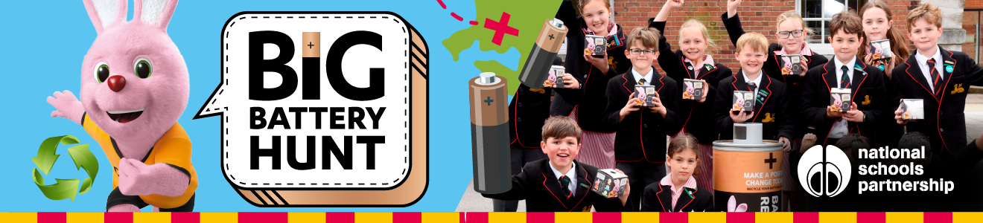

-----------------------------------------------------------------------------------------------------------------------
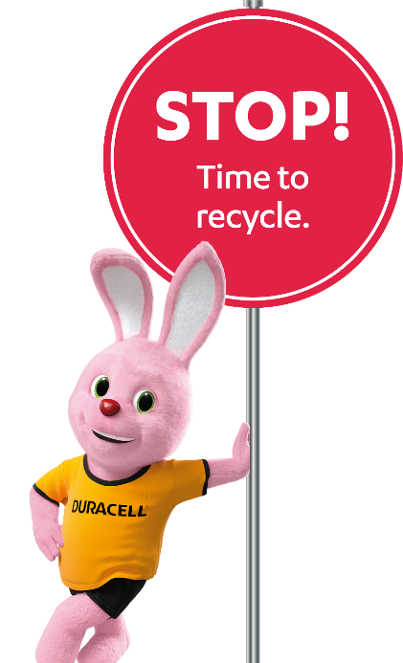
My Big Battery Hunt Collection numbers

Pupil Name: _________________________________
Class: ________________________________________


I have collected _____________________ batteries!

Please return to Mrs Tarrant, you can even include a photo to go on the eco board.

